**WorkFlow Documentation**

**Description**

Microsoft Flow is a service that helps you create automated workflows between your favorite apps and services to synchronize files, get notifications, collect data, and more.

**Steps to Start with Microsoft Flow**

1. Sign up or sign in from this link : <sign-up_sign-in> (if you have Office 365 Email you will not need to sign up )
2. To start with Twmpletes Go to this link : <Templates>
3. if you already have a process in mind and can't find a template for it Go to this link : [Create Flow from Scratch](Create%20Flow%20from%20Scratch)

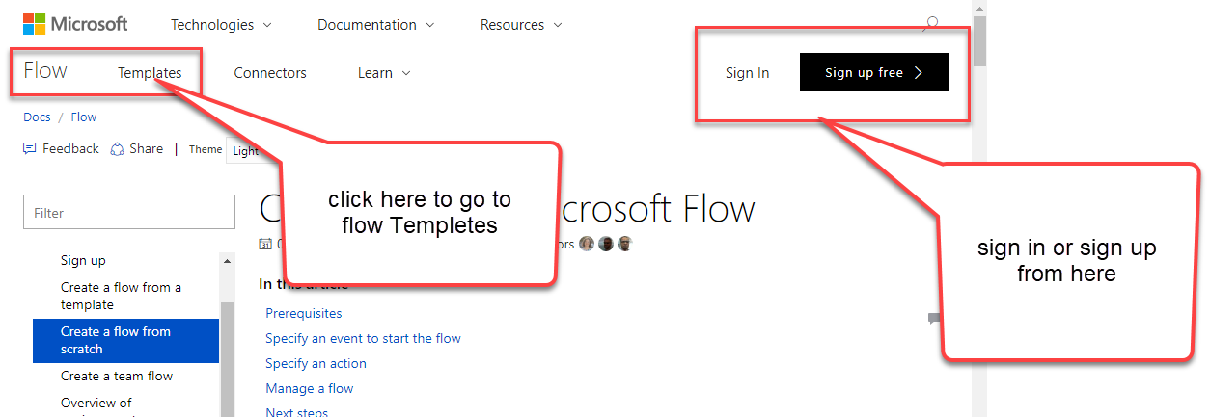

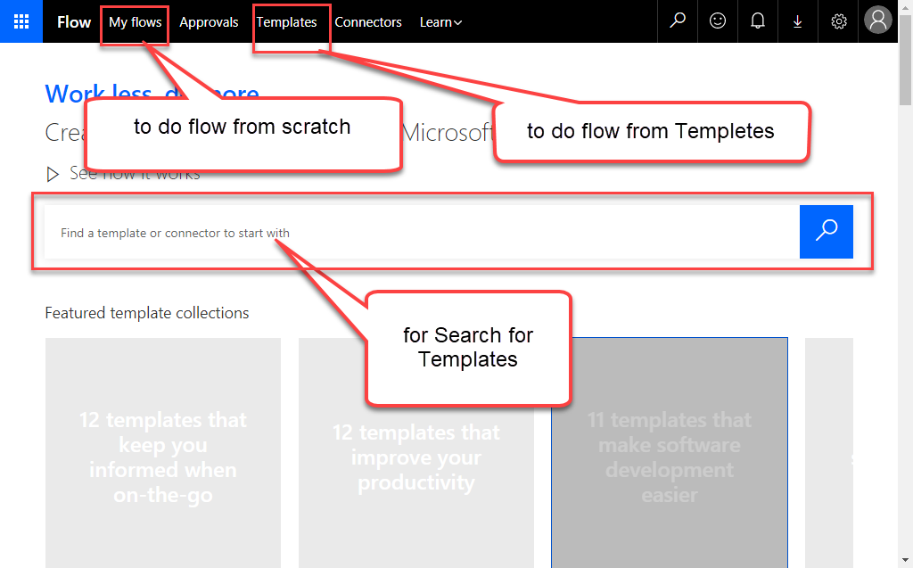

**Steps to Make New Flow**

1. Create a flow from a template
2. Go to this link : <https://us.flow.microsoft.com/en-us/templates/>
3. You can find all what you need categorized also you can search for what you need .  
   (Examples : if you need to do action After Clicking button choose Category Button if you need an application to send Email to you after doing some actions Choose Email you will find a lot of Templates to do what you need )
4. You can also search for any determined Services like Slack
5. You'll see only templates related to Slack, so you can now select Send a message on Slack when my manager emails me.

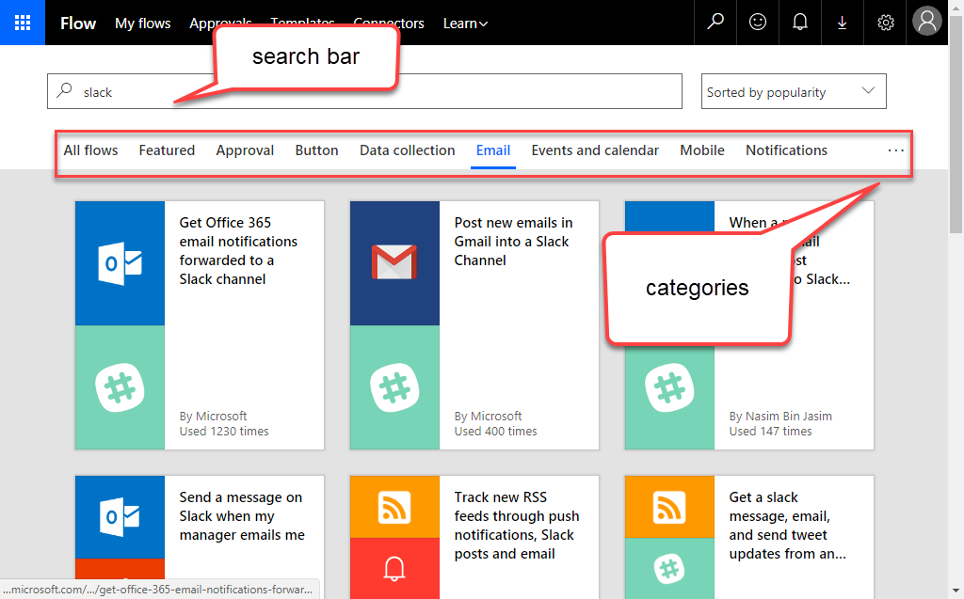

For Example I will Show you how to use Flow to Collect data

1. From category Data Collection I will choose a template (Log Gmail emails to an Excel file) that used to Track everything sent to your Gmail Inbox in an Excel file. You will have to select an Excel file that has a Table with columns for Subject, From, Date, and Snippet.
2. Sign in your Gmail in this Flow Tempate
3. Create Excel Sheet that has a Table with columns for Subject, From, Date, and Snippet.

Generally any template you will do will give you some prerequest to do first like this

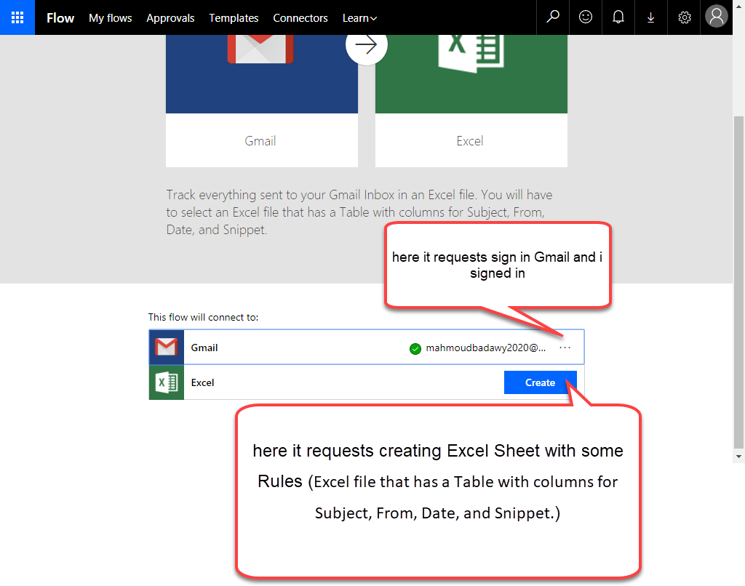

1. When you click Create that belong to Excel it will show you this list for doing Excel on and connect Gmail with

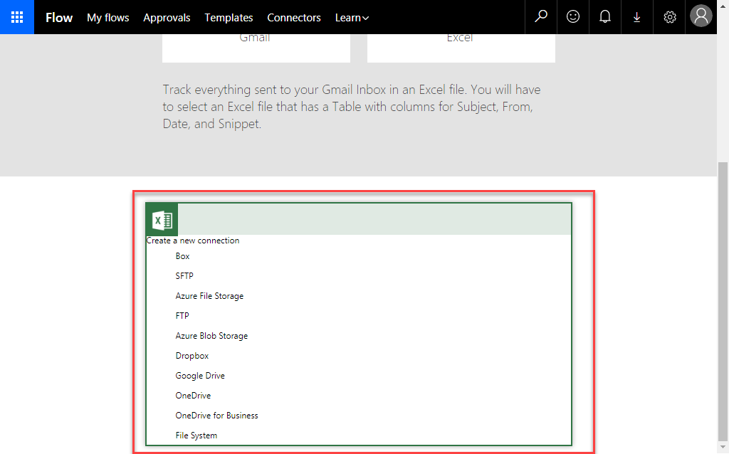

1. Choose any thing you want (with me I will Try Google Drive for Save there)

If you want to work on Google Drive So first

1. You should create Excel File in your Pc with Any name with me I choose this name (Excel\_MB\_Gmail\_Inbox)
2. Then you should create Empty Table in Excel sheet which will import data in and also you should make headers the same like that (do 1 row for table and it will create rows after the first row automatically )

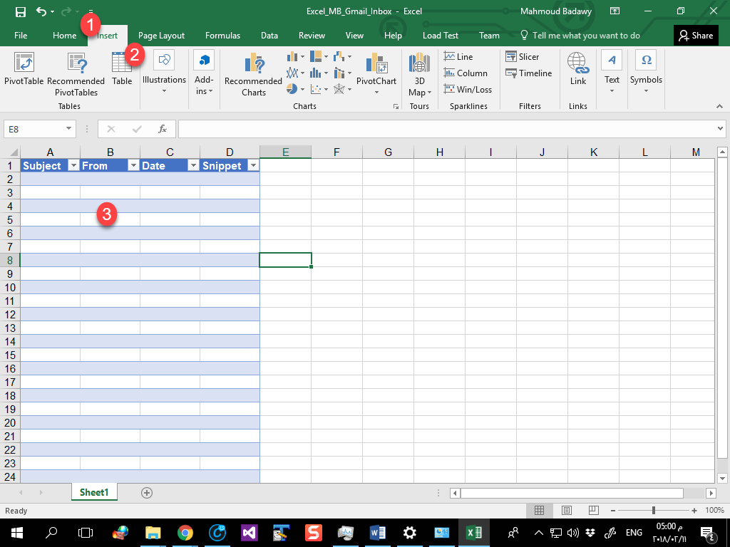

1. After Creating Excel file Upload it in Google Drive
2. Then continue

To Ensure that all thing is ok you will see the connections with green right Symbol if you saw that click Continue

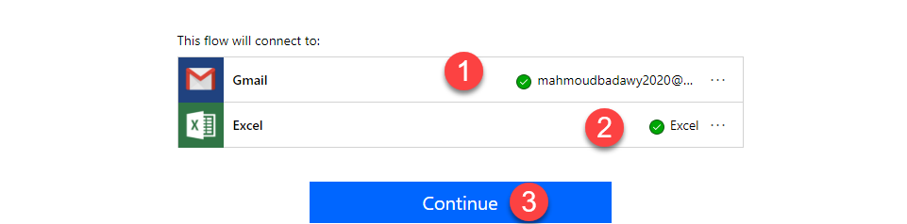

1. After Clicking Continue you will find these form that you need to fill

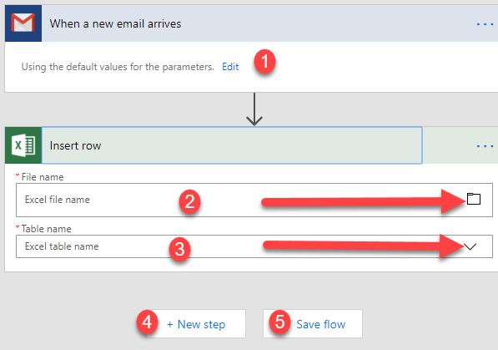

1. Click on Edit (1) and choose Email box You want for me I Choose 3545Consulting
2. In File Name (2) Click The Symbol of folder and Choose the Excel File You Uplaod it will be (/Excel\_MB\_Gmail\_Inbox.xlsx)
3. And Table name I will choose it From Table Name (2) it will be (Table 1)

So All Of things will be like that

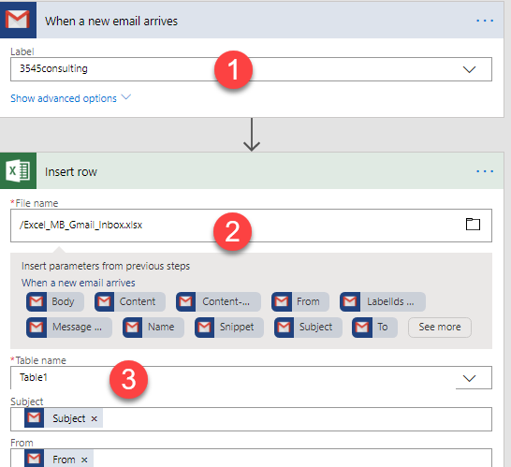

All of thing is Ok now You can Click (Save Flow) if you want to Save What you want

And Also you can increase Actions in this Flow by Clicking Next Step and try to Add another Action

After Clicking Save Flow you will find this Message that you mean your work is done well .

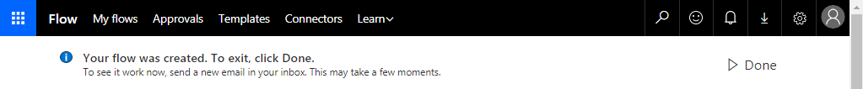

Click Done and test flow you done

1. Create a flow from a Scratch
2. Click on My Flow
3. Click on Creat From Blank
4. Start to do your own Flow

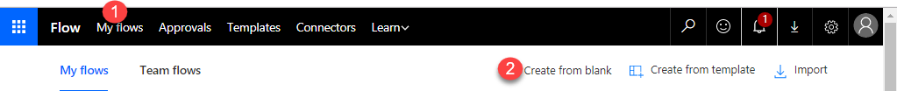

1. You can start with Choose any app or search for any one to start by

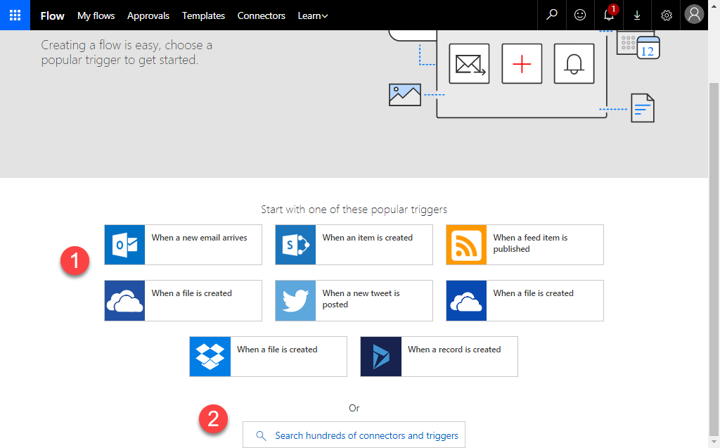

1. For me I will start with Outlook so I will start with Trigger (when a new Email Arrives )
2. Change the name of Flow then Choose Email Box that Arrive Emails from Dropbox (this Email box When any Email arrive there the action in Flow will be done ) for me I choose outlook Inbox
3. Then I will Click on Next step to Add a new Action or Condition to do a new action

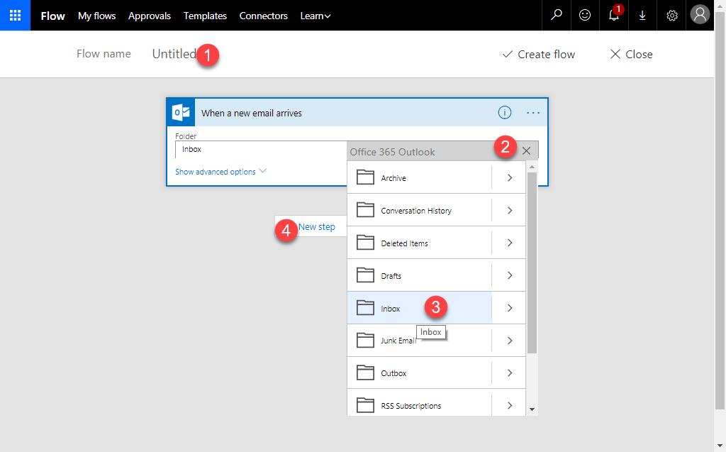

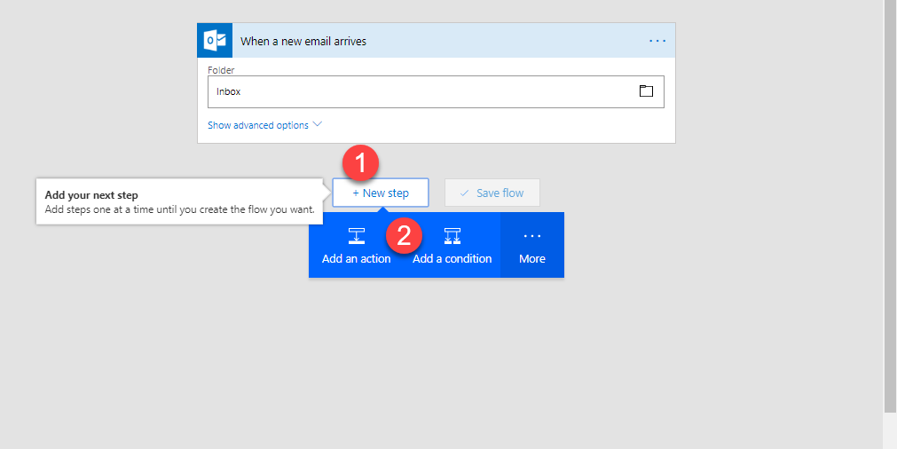

1. For me I will Choose Add Condition as I will do condition for Doing new action
2. I will do flow that make when Email arrives in outlook inbox and this Email contains “mahmoud” in (From) it will send it to me in Excel sheet I uploaded it in Google Drive
3. So I will Click Add condition now and show you what I will do in Photo

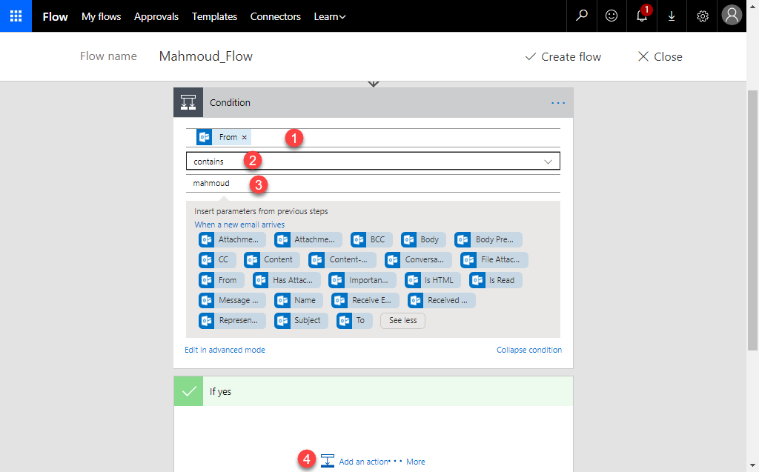

1. In condition I Choose from as Email will send by any one but if From Emails Contains String (Mahmoud) the condition will be yes and if not the condition will be No
2. So I have to put not the action if the condition yes and the action when condition No
3. When Yes : send Email ( From , Date , subject , body , Message ID ) to Excel Sheet you Upload in Google Drive so you should first Make Excel Sheet in your Pc then Create table that has (Email From , Date , subject , body , Message ID ) columns then Upload it to Google Drive Then Connect Excel sheet with Flow

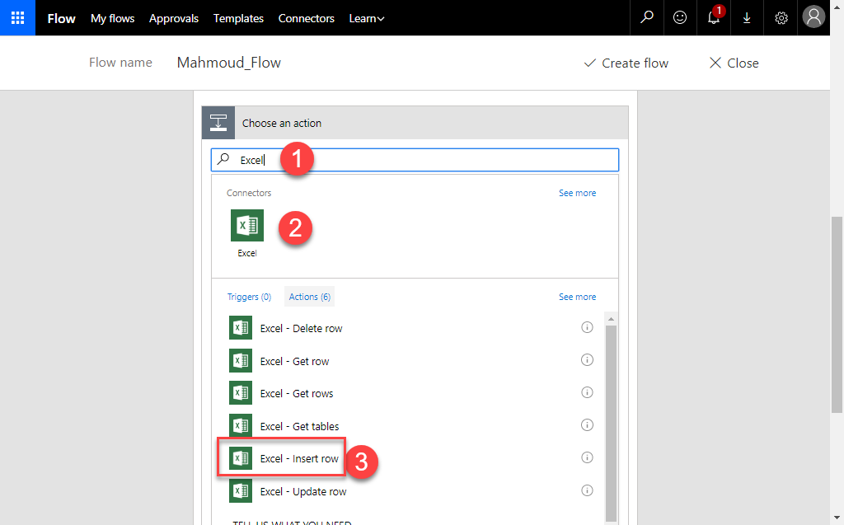

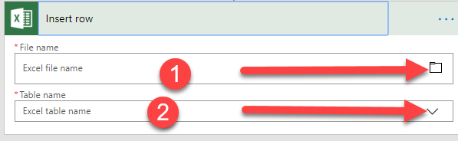

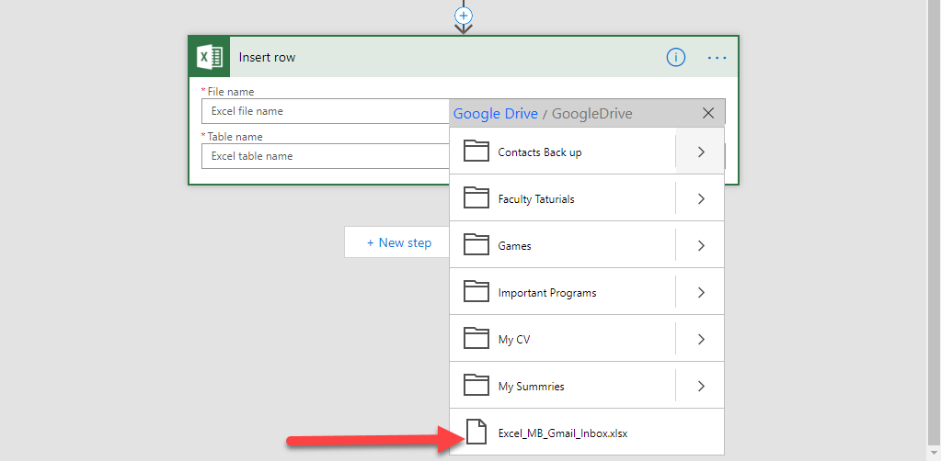

Choose Excel Sheet in Google Drive and Choose table you need to fill Data on it in Excel

(as you can create 10000000 table and fill what you need :)

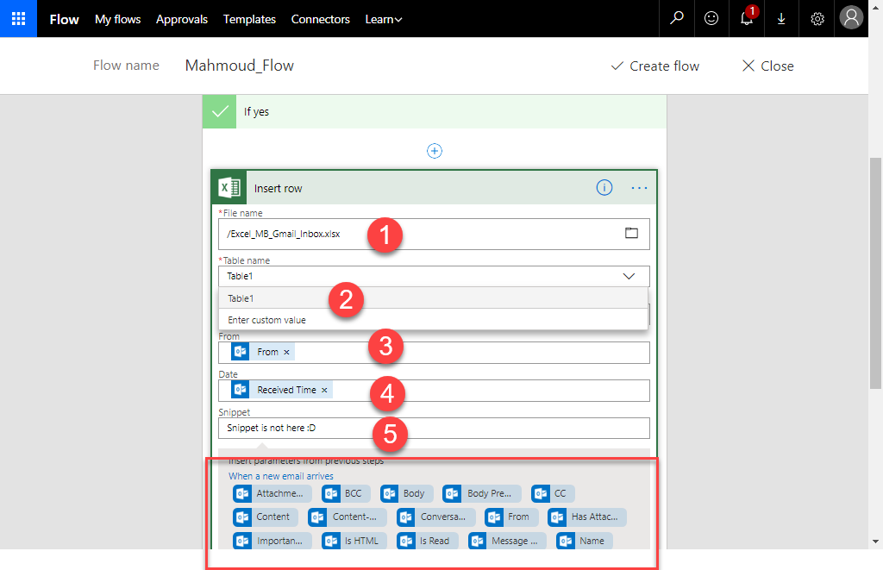

1. When No Do no thing so I will leave it with no adding or editing  
   then I will Click on Create Flow

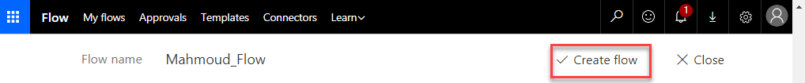

1. Now Go to test this flow By sending Email from Email Contains (Mahmoud ) as My Email : [mahmoudbadawy2020@gmail.com](mailto:mahmoudbadawy2020@gmail.com)

You will find that Excel sheet will take data from my Email to Excel Sheet as I request

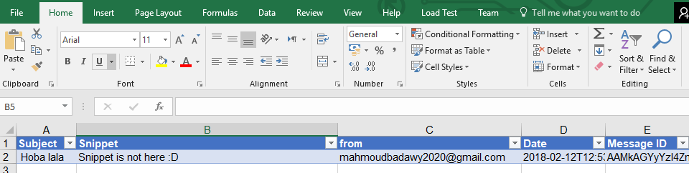

**How to Send Email For List Of Emails when some body add Excel File in determined Folder**

---------------------------------------------------------------------------------------------

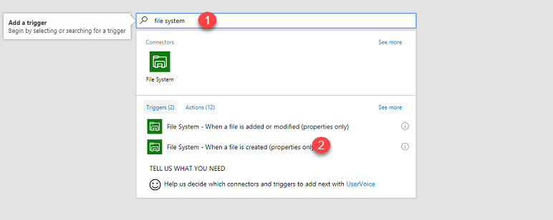

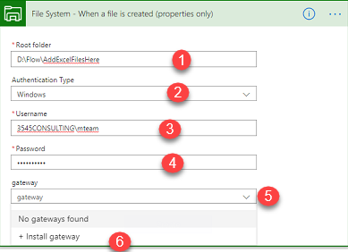

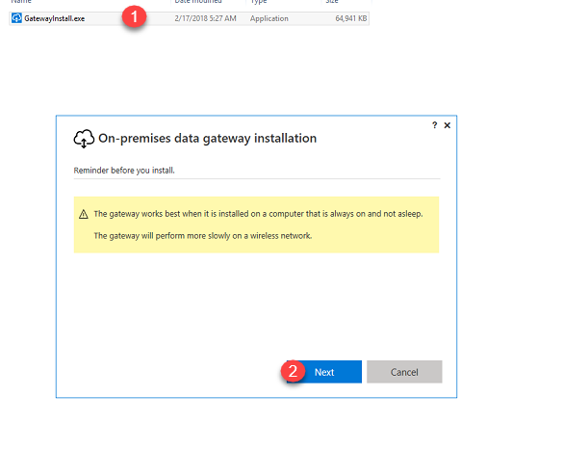

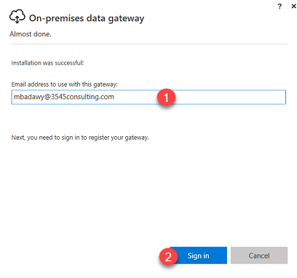

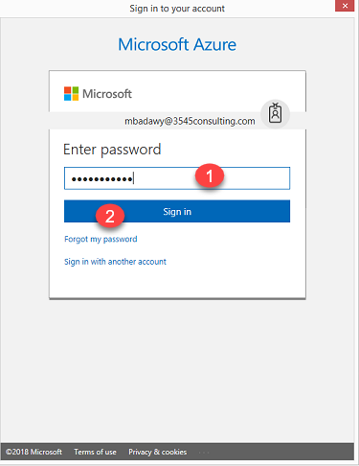

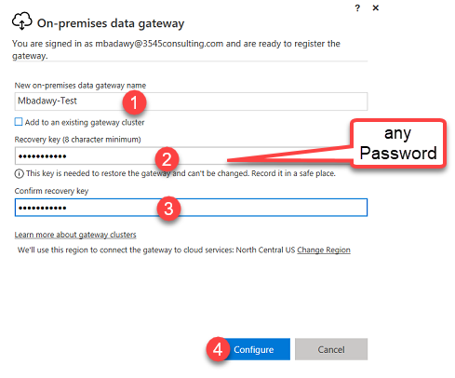

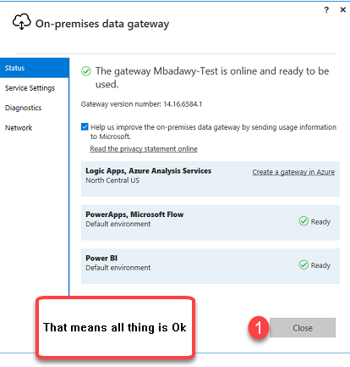

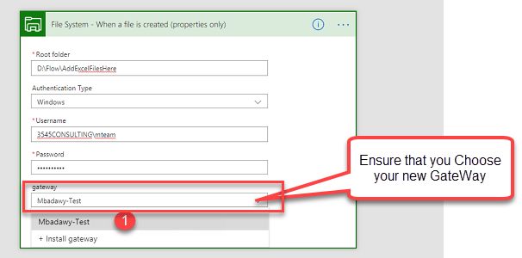

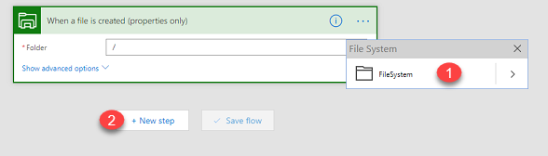

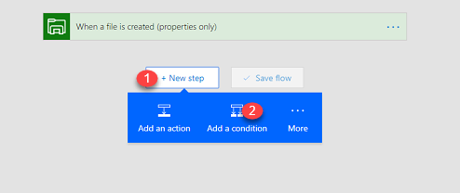

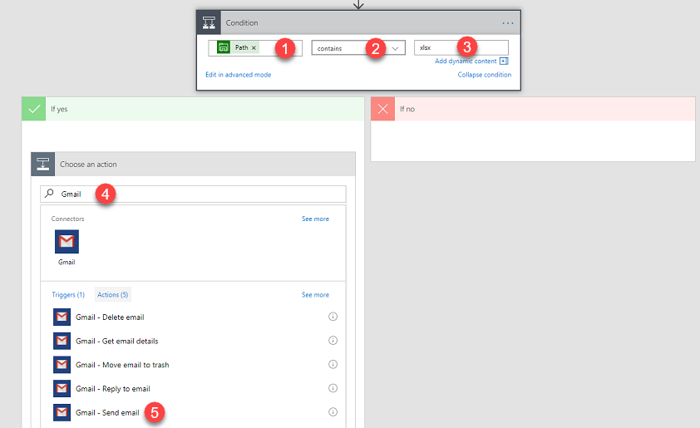

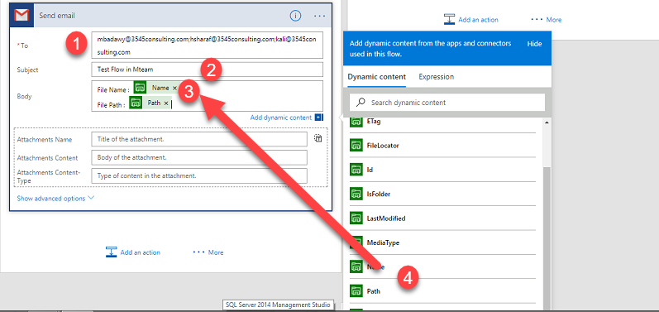

Then Save Flow and try to add or Create Excel File in this folder path   
D:\Flow\AddExcelFilesHere

which you determine

Email Will Sent to All list Of Emails You Write

I Wrote list of Emails here Manually but I can Put list of Emails in Excel File and Call All in Flow that will make All Thing Easier

I use Excel sheet that Contain List Of Emails I upload in Google Drive  
the Flow new Step only and new Structure is

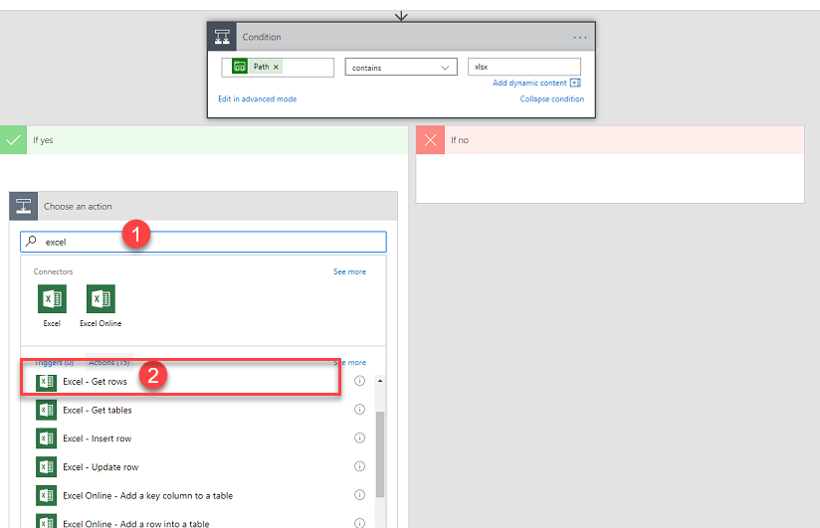

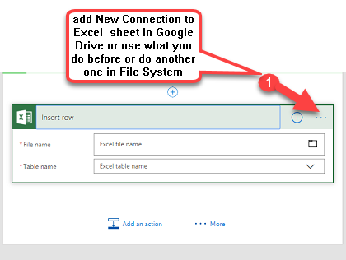

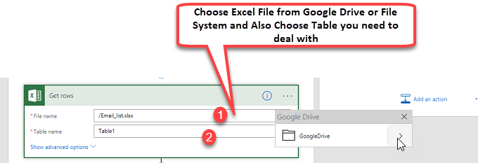

**This is Flow Structure**

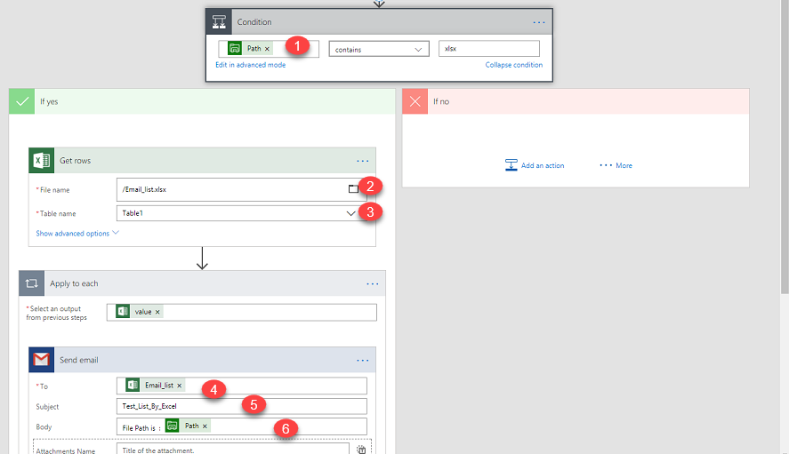

Watch this

This is tools that Flow Connect it together

------------------------------------------------------

 Office 365 Outlook



SharePoint



RSS



Twitter



Outlook.com



OneDrive for Business



Google Calendar



Gmail



OneDrive

Request



Dropbox



Dynamics 365



10to8 Appointment Scheduling



Act!



Adobe Creative Cloud



Adobe Sign



Amazon Redshift



Apache Impala



Appfigures

Approvals



Asana



AWeber



Azure AD



Azure Application Insights



Azure Automation



Azure Blob Storage



Azure Container Instance



Azure Cosmos DB



Azure Data Lake



Azure Event Grid



Azure Event Grid Publish



Azure File Storage



Azure Kusto



Azure Log Analytics



Azure Log Analytics Data Collector



Azure Queues



Azure Resource Manager

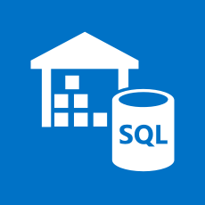

Azure SQL Data Warehouse



Azure Table Storage



Basecamp 2



Basecamp 3



Benchmark Email



Bing Maps



Bing Search



Bitbucket



Bitly



Bizzy (H3 Solutions, Inc.)



Blogger



Box



bttn



Buffer



Calendly



Campfire



Capsule CRM



Chatter



Cognito Forms



Common Data Service



Common Data Service (experimental)



Computer Vision API



Content Conversion



Content Moderator

Control



Custom Vision



D&B Optimizer

Data Operations

Date Time



DB2



Derdack SIGNL4



Disqus



DocFusion365 – SP



Docparser



DocuSign



Dynamics 365 for Financials



Dynamics 365 for Operations



Dynamics NAV



Easy Redmine

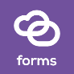

Elastic Forms



Enadoc



Event Hubs



Eventbrite

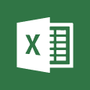

Excel



Face API



Facebook



File System



Flic



Flow management



FlowForma



FreshBooks



Freshdesk



Freshservice



FTP



GitHub



Google Contacts



Google Drive



Google Sheets



Google Tasks



GoToMeeting



GoToTraining



GoToWebinar



Harvest



HelloSign



HipChat

HTTP



HTTP with Azure AD



iAuditor



Infobip



Informix



Infusionsoft



Inoreader



Insightly



Instagram



Instapaper



Intercom



JIRA



JotForm



kintone



LeanKit



LinkedIn



LiveChat



Logic flows



LUIS



MailChimp



Mandrill



Medium



Metatask



Microsoft Forms



Microsoft Kaizala



Microsoft StaffHub



Microsoft Teams



Microsoft To-Do



Microsoft Translator



MSN Weather



Muhimbi PDF



MySQL



Nexmo

Notifications



Office 365 Groups



Office 365 Users



Office 365 Video

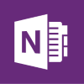

OneNote (Business)



Oracle Database



Outlook Customer Manager



Outlook Tasks



PagerDuty



Parserr



Paylocity



Pinterest



Pipedrive



Pitney Bowes Data Validation



Pivotal Tracker



Planner



Plivo



Plumsail Documents



Plumsail Forms



Plumsail SP



PostgreSQL



Power BI

PowerApps



PowerApps Notification



Powerflows



Project Online



QnA Maker



Redmine



Salesforce



SendGrid



Service Bus



ServiceNow



SFTP



Skype for Business



Slack



Smartsheet



SMTP



SparkPost



SQL Server



Stripe



SurveyMonkey



Tago



Teamwork Projects



Teradata



Text Analytics



Todoist



Toodledo



Trello



Twilio



Typeform



UserVoice

Variables



Video Indexer



Vimeo



Visual Studio Team Services



WebMerge



WordPress



Workday HCM



Wunderlist



Yammer



YouTube



Zendesk